Python Assignment 2: Data Structures - List, Dictionary, Set & Conditional Statements

1.List (Creation, Modification and Access):
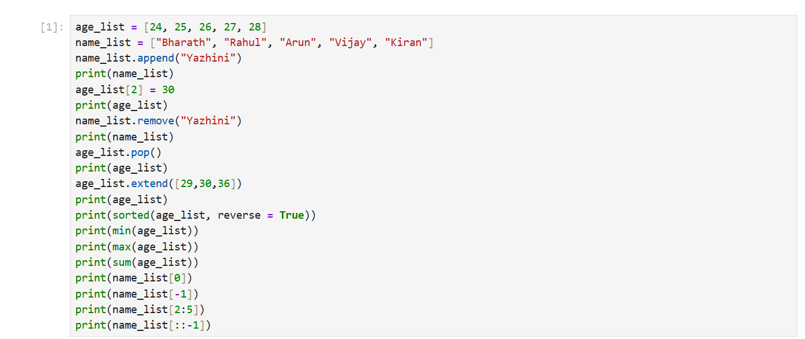
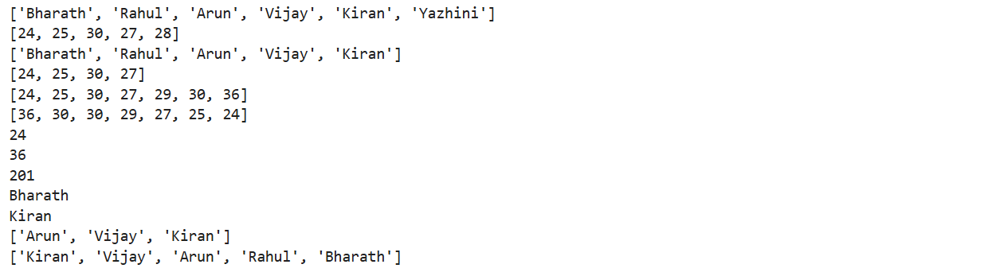

2. Dictionary (Creation, Modification and Access)

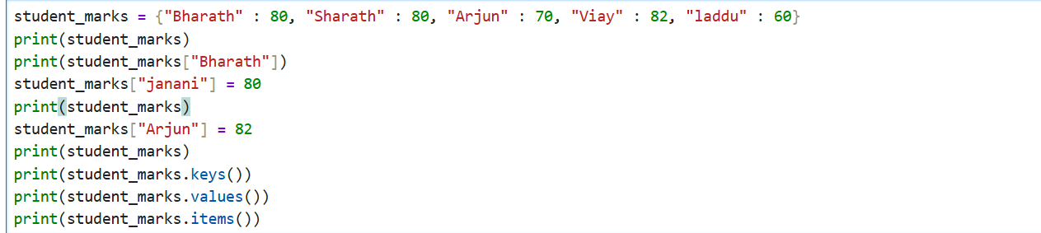

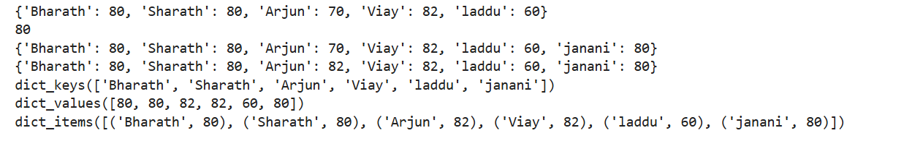

3.Sets (Operations):
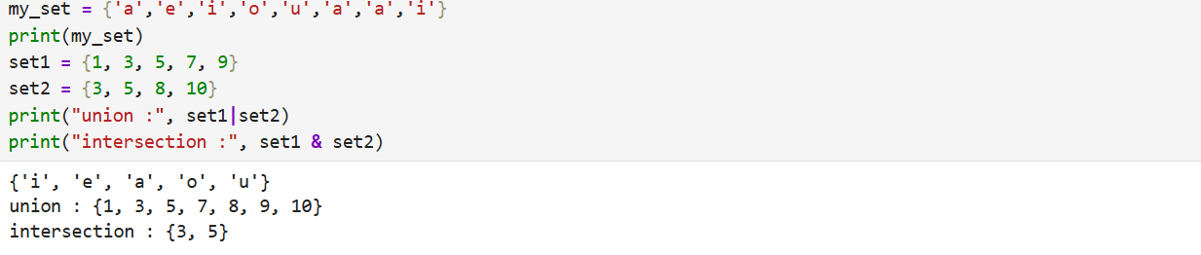

4. Operators & Conditional Statements:
(IF, ELIF, ELSE)
